Project Proposal

On

Online News Portal.



Name: Reshika Bhasink.

Student Id: 170340

Batch No.: 22’D’

Email: [reshikabhasink@gmail.com](mailto:reshikabhasink@gmail.com)

Softwarica College of IT & E-Commerce

April 9, 2019

# Chapter 1: Introduction

Project Introduction.

The project I am working on is an Online News Portal. Nowadays, we live in age of Information Communication and Technology. We can’t even think a single moment without technology. From morning to night, we need help of technology. Most of the works depends upon web application. This news portal will save the time of users in this busy world and helps them to improve their awareness.

Justification for Project.

Background of the Project.

Basically, an Online News Portal is the online version of a newspaper, either as a stand-alone publication or as the online version of a printed periodically. This portal provides up-to-date information in internet about all the news. The portal will reside of sections addressing different information needs. This system will indeed save the time of users. Users can view the news according to their wish such as Bollywood, movies, nationals and internationals, business etc.

Problem Statement.

To read a newspaper one must go to nearest shop and buy one. Some people don’t even have that much time to read newspaper. They buy them and forget to read it because of their busy schedule. The proposed system will overcome all of the problems. Such as it saves time as well as money of users. one need not turn on TV or Radio to get news they can check it out whenever they are in work. They are also good in terms of environment as no more paper are

Description of the Project.

Features

* Online News Portal allows customers to read up to date news related to various field like Politics, Sports, Education, Business, Bollywood, Hollywood etc.
* Without payment or login, he/she can also contact us to give suggestions and can give us feedback related to our site.
* New news can be added or posted only by admin and only admin have the authority to update or delete any news.
* Admin have the right to give authority to other for News update, add or delete.

Overview of the Project.

In this project I have made an attempt to develop a News or Information based website. This project helps people and makes them aware so that they can know any news. Various methodologies shall be used to develop this website.

# Chapter 2: Scope of the Project.

Scope

A lot of project has been made on online news portal. Various online newspaper is available at present time. But most of those are static and traditional and doesn’t include the feature that helps in awareness. Our project has various features that provides awareness and this helps people to get more and more information in their daily life.

Limitation

The major limitation of this portal is it could crash if many people are trying to access it at the same time

Aims

* The major aim of this project is to save the time of the users so that they don’t have to wait for the newspaper in the morning.
* News of all categories shall be uploaded in this by the use of databases and real-time algorithms.

Objectives

* The objective of this project is to develop a web application for Online News Paper Website that can aware people.
* To provide daily news.
* Anytime, anywhere people can get information through internet in a low cost.
* It makes use of various technologies to get required crime-oriented information more easily and quickly.

# Chapter 3: Development Methodology.

Waterfall Methodology.

Waterfall model is the first approach used in software development. In this methodology, one step must be completed before going to another step. For the project I have used Waterfall methodology. Output of one step is input for next step. Steps involved in the process are divided into six steps i.e. Requirement analysis, Design, Implementation, Testing, Deployment, Maintenance.

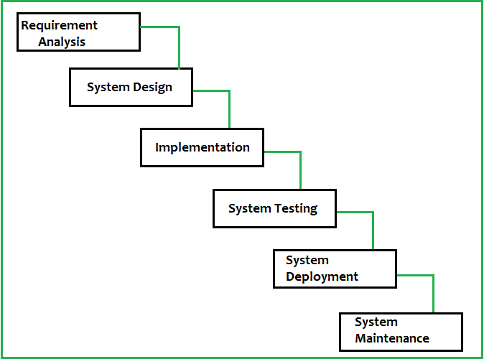

Figure : Waterfall Model

Design Pattern.

Design patterns are reusable solutions for the commonly occurring problems. I am using MVC pattern in this project. MVC Pattern stands for Model-View-Controller Pattern. This pattern is used to separate application's concerns.

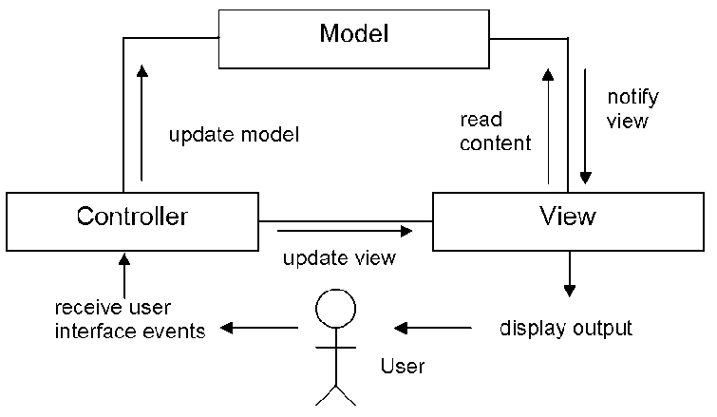

Figure : Model View Controller

* **Model** - Model represents an object or JAVA POJO carrying data. It can also have logic to update controller if its data changes.
* **View** - View represents the visualization of the data that model contains.
* **Controller** - Controller acts on both model and view. It controls the data flow into model object and updates the view whenever data changes. It keeps view and model separate.

System Architecture.

A system architecture is the conceptual model that defines the structure, behavior, and more views of a system. An architecture description is a formal description and representation of a system, organized in a way that supports reasoning about the structure and behavior of the system. I have used 3-tier structure for this project.

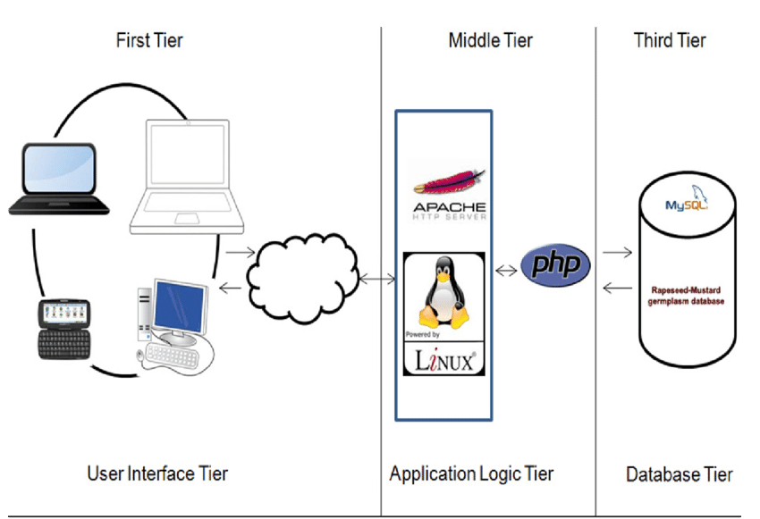

Figure : 3-tier architecture